2019-2020 Manual

Contents

Admissions Mission 2
Goals of ASIST 2
Your Role as an ASIST Member 2
ASIST Contact Information 3
Statement of Principles of Good Practice 4
Orientation 8
On Iowa! 9
Athletics 10
Admission Requirements 13
New Buildings 15
University of Iowa Alumni Association—Iowa Clubs 16
College Fairs 17
Engineering ASIST 21
Education ASIST 24
Iowa Firsts and Notable Alumni 27

Admissions Mission

Through its programs and services, the Office of Admissions develops successful admission and transition strategies which serve the larger institutional objectives of teaching, research and service. A component of Enrollment Management in the Office of the Provost, Admissions works actively with central administrators, college deans, faculty, staff, students and alumni to attract and maintain a diverse, talented, multicultural student body of appropriate size and composition that will matriculate, persist, achieve academically and graduate from the University.

Goals of ASIST

- To identify and train volunteers for progressive and active involvement in student recruitment.
- To enhance students’ access to The University of Iowa from their local communities.
- To individualize the admission process for an increasing number of qualified applicants.
- To increase the percentage of qualified and talented students enrolling at The University of Iowa.
- To attract a variety of applicants from different cultural, geographic, and socioeconomic backgrounds.

Your Role as an ASIST Member

The primary role of the ASIST member is to support the goals of the Office of Admissions and its professional staff. Your positive experiences and knowledge of Iowa City make you a valuable resource of the University. It is, however, important to remember that the admissions professional has been hired and trained in the field of admissions and makes the final decisions concerning appropriate marketing strategies, admission-related programming, and the admitting of students to the University. The ASIST member plays an important supportive role which may be innovative, and certainly vital, in shaping the reputation of the University, especially as it relates to the recruitment of prospective students.

Through your ASIST membership you will:

- Play an active role in improving the quality and reputation of The University of Iowa.
- Be a member of a select group of volunteers directly in contact with future Hawkeyes.
- Interact with fellow volunteers who share a common set of experiences.
- Be influential in directing the overall mission of the University.
- Be involved in enhancing the educational options within your community.

ASIST member responsibilities include:

- Make a volunteer commitment of at least one year.
- Commit to being an engaged volunteer to help identify and contact prospective students.
- Follow the Statement of Principles of Good Practice (on the following page) as described by the National Association for College Admission Counseling (NACAC).
- Ask questions or offer suggestions that would help to improve program participation or effectiveness.
- Notify the Office of Admissions if you are unable to complete a request or commitment. Please provide the ASIST coordinator with updated information regarding any changes of address, phone number, e-mail, etc.

ASIST Contact Information
Admission Visitors Center
100 Pomerantz Center, Room C110
Iowa City, IA 52242-7700

Receptionist: (319) 335-1566
FAX: (319) 353-2940
E-mail: ADM-UI-ASIST@uiowa.edu
Internet: foriowa.org/asist/
ASIST Blog: asist.admissions.uiowa.edu

Rachel Ahern
ASIST Coordinator |Admission Counselor
Direct dial: (319) 335-2440
Email: rachel-ahern@uiowa.edu

Tina Merta
ASIST College Fair Coordinator
E-mail: tina-merta@uiowa.edu

UI Center for Advancement
Heather Wilensky
Executive Director-Alumni Engagement

Toll free: 1-800-648-6973
Direct dial: (319) 467-3368
Internet: foriowa.org/asist/

Statement of Principles of Good Practice: NACAC’s Code of Ethics and Professional Practices

“Postsecondary education has the power to transform an individual’s life by providing a path to personal fulfillment, a meaningful career, and the realization of dreams. Its power can lead our society to a future that includes engaged citizens and a more prosperous 21st century.

College admission and counseling professionals help students make thoughtful choices about their futures. Our work is guided by principles of honesty, integrity, transparency, equity, fairness, and respect for students and fellow professionals. These values guide us in our service to students and families, our institutions, society, and each other.

Promoting ethical admission practices has been the cornerstone of the National Association for College Admission Counseling (NACAC) since our founding in 1937. The Statement of Principles of Good Practice, which with publication of this document is renamed SPGP: NACAC’s Code of Ethics and Professional Practices, protects the interests of both students and institutions by upholding a college admission process free from coercion and discrimination. The SPGP: NACAC’s Code of Ethics and Professional Practices serves as the basis of our profession and an affirmation of what we stand for.

Our profession strives to ensure that the students we serve and all of our colleagues are valued and supported. We thrive by embracing and engaging our unique identities, experiences, and perspectives, and we are committed to increasing the enrollment and success of historically underrepresented populations. We are dedicated to promoting college access and addressing systemic inequities to ensure that college campuses reflect our society’s many cultures, stimulate the exchange of ideas, value differences, and prepare our students to become global citizens and leaders.

The SPGP: NACAC’s Code of Ethics and Professional Practices is the conscience of our profession. It guides our actions in the face of current and emerging pressures. It empowers us to build trust and find common ground while we work to ensure that every student’s dignity, worth, and potential are realized in the transition to postsecondary education.”

The University of Iowa subscribes to the Statement of Principles of Good Practice for its staff and volunteer members of the ASIST program. The following are relevant excerpts for admission volunteers:

Core Values

- Education
- Fairness and Equity
- Professionalism
- Civility
- Collaboration
- Trust
- Social Responsibility

Truthfulness and Transparency: Guiding Principles and Rationale Counseling professionals must provide their students and colleges with complete, truthful, and factual information that will allow them to make informed decisions. Colleges are equally obligated to provide complete, factual, and readily accessible information that will allow students and their counselors to make informed college comparisons and choices.
- All members agree they will accurately describe, represent, and promote their schools, institutions, organizations, and services to students and to colleagues and will not misrepresent themselves or their institutions. This includes the data that appear on profiles, websites, and promotional materials and data that are reported to the government, private agencies, and the media
- When they share information about students, it will be relevant to the college admission process and will be accurate, up-to-date, complete, and free from misrepresentations of fact or material omissions
- Comply with all local, state, provincial, and federal laws and lawful regulations.
- Colleges must make publicly available accurate, complete, and current information concerning: deadlines for applying for admission, scholarships, financial aid, and housing
- The factors considered in making admission, financial aid, and scholarship decisions, including, but not limited to, students’ demonstrated interest, social media presence, personal conduct, legacy status, and financial need
- Academic majors and other academic offerings and programs, such as honors programs, off campus study, conditional admission, and postgraduation outcomes
- The availability and selection process for institutional housing, deadline dates for housing deposits, housing deposit refunds, and policies for renewal of institutional housing costs and the availability of scholarships and financial aid.

Professional Conduct: Guiding Principles and Rationale Advocating for the best interests of students in the admission process is the primary ethical concern of our profession. This requires that students receive college admission counseling that they can trust. Members will therefore adhere to high standards of individual and institutional professional conduct. Conflicts of interest, whether real or perceived, and unprofessional conduct undermine that trust. Similarly, secondary schools, colleges, individuals, and NACAC member organizations and agencies should work together in an environment that fosters that trust. Public discourse that is based on false or incomplete information, hearsay, or malice is detrimental to that environment and to the fair and ethical practices necessary for the equitable recruitment of students.
- To provide college counseling in the best interest of students, members will: provide guidance and information to help students determine their best academic, personal, and financial college match
- To avoid conflicts of interest and the appearance of unethical behavior, members will: not be compensated by commissions, bonuses, or other incentive payments based on the number of students referred, recruited, admitted, or enrolled. The use of commissioned agents to recruit students who are neither US citizens nor US permanent residents is a recognized exception (See Section II.E., The Use of Commissioned Agents in International Student Recruitment)
- Not offer or accept any reward or remuneration to influence an admission, housing, scholarship, financial aid, or enrollment decision
- Ensure that representatives, including individuals, vendors, consultants, agents, or agencies, will adhere to the SPGP: NACAC’s Code of Ethics and Professional Practices while acting on the institution’s behalf.
- To maintain a culture of professional civility and respect, members will not: disseminate inaccurate or misleading information about other secondary schools, colleges, organizations, or individual professionals

Respect for Confidentiality: Guiding Principles and Rationale The college admission and counseling community depends on trust. An important component in building that trust is a respect for confidentiality.
- Members will send and receive information about candidates in confidence and will protect the confidentiality of all information that is shared.
- College members will not ask candidates, their counselors, their schools, or others to divulge or rank order their college preferences on applications or other documents. They may ask the question verbally only if the answer will not be used to influence an admission, scholarship, or financial aid decision.

Admission Cycle Dates, Deadlines, and Procedures for First-Time Fall Entry Undergraduates: Guiding Principles and Rationale College choices should be informed, well-considered, and free from coercion. Students require a reasonable amount of time to identify their college choices; complete applications for admission, financial aid, and scholarships; and decide which offer of admission to accept. Once students have committed themselves to a college, other colleges must respect that choice and cease recruiting them. Similarly, colleges need protection when other institutions pressure students to submit applications or enrollment deposits before established deadlines or when they continue to solicit applications or enrollments after students have finalized their college decisions.
- October 15: This date is the earliest deadline colleges may require first-year candidates to submit an application for fall admission.
- Notification of admission: Members must not notify first-year candidates of their fall admission before the official completion of their junior year of secondary school or its equivalent.
- Notification of financial aid: Colleges must notify accepted aid applicants of financial aid decisions at least two weeks before the institutional enrollment confirmation deadline, so long as the candidates have submitted all requested application forms and supporting materials by the designated priority deadline.
- Notification requirements for wait list procedures are a recognized exception.
- May 1—National Candidates Reply Date: Colleges must permit first-year candidates for fall admission to choose among offers of admission and institutional financial aid and scholarships until May 1.
- Binding Early Decision plans and recipients of athletic scholarships are recognized exceptions.
- Colleges will not guarantee admission, specific college placement, or institutional financial aid or scholarship awards prior to an application being submitted, except when preexisting criteria are stated in official publications.
- Colleges must state the May 1 deadline explicitly in their offers of admission and clearly indicate whether deposits submitted prior to May 1 are refundable or non-refundable.
- The May 1 deadline also applies to any academic major, institutional scholarship, or special program to which the candidate has been offered admission. Examples of special programs may include honors programs and dual-enrollment graduate or professional degree programs.
- Housing assignments and May 1 Colleges must not use on-campus housing assignments to manipulate enrollment commitments prior to May 1. The only exception occurs when colleges are unable to house all their first-year students.
- Colleges will not knowingly recruit or offer enrollment incentives to students who are already enrolled, registered, have declared their intent, or submitted contractual deposits to other institutions.

SPGP: NACAC’s Code of Ethics and Professional Practices document can be viewed at: www.nacacnet.org/cepp

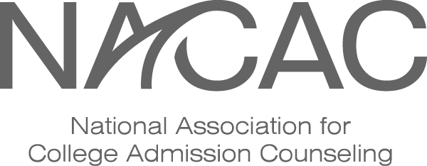
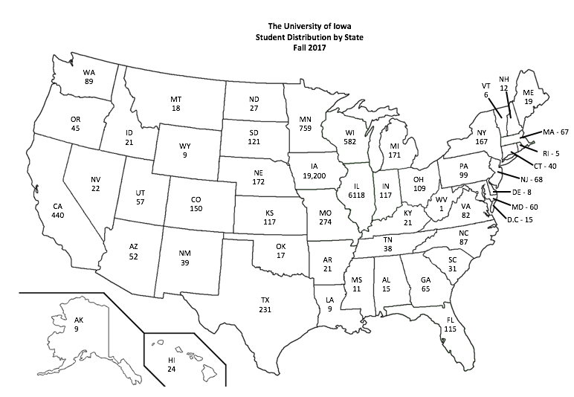

Diversity is a Core Value at The University of Iowa
“Across the strategic focus areas and in all that we do, the University will continue to advance the core values and priorities of inclusion and internationalization. Domestic and global diversity are essential to excellence across all parts of our mission.”

Orientation

Orientation is designed to formally introduce new students and their families to the University. A primary goal of the Orientation program is to assist students with course selection, schedule building, and registration. Orientation programs are also designed to acquaint students with educational facilities, student services, and other UI resources, while allowing them to meet new people and have their questions answered about college life.

Entering first-year students who have accepted their offer of admission and paid their Acceptance Fee are invited to register for Orientation beginning in March. Most Orientation programs for first-year students (freshmen) are one-and-a-half-day sessions which take place in late May, June or early July prior to the start of the fall semester. For students who are not able to attend one of these programs, there are one-day Orientation programs offered the week before classes begin, though the one-and-a-half-day sessions are highly encouraged.

All new students are required to attend Orientation. Family members are encouraged to attend a separate but concurrent Orientation program, which will allow them to learn about academics, University policies and procedures, and campus resources for students.

Prior to coming to Orientation, every first-year student will take the ALEKS online mathematics placement test. Depending upon the student’s major and High School academic background, Chemistry Diagnostic and World Language placement tests may also need to be completed. These placement tests are taken fully online and are typically accessible after May 1st. It is requested that all students complete their placement tests no later than 2 weeks prior to their orientation date.

During Orientation, students will:

- Meet new people and get to know other new students
- Work with an Orientation Hawkeye Guide (and professional academic advisors) to learn about basic academic requirements
- Select their courses for the fall semester and create their academic schedule
- Meet with their assigned academic advisor
- Register for classes MyUI
- Have an opportunity to learn about residence hall living, how to get involved on campus, the academic expectations of faculty, fraternity and sorority life, computing technology on campus, and much more!

There is no fee to attend an Orientation program.

Orientation sessions for transfer students are one-day programs that occur at different times throughout the year prior to each semester. Transfer students are required to attend an Orientation program in order to register for their classes and may reserve their date online via MyUI.

Orientation Services
310 Calvin Hall
(319) 335-1497
https://newstudents.uiowa.edu/orientation

On Iowa!
On Iowa! is a welcome event in which all members of the incoming class are required to participate. On Iowa! begins 4-5 days prior to the start of the fall semester. One of the first activities that students partake in on the Friday before classes begins is Kickoff at Kinnick. There, students were welcomed by a surprise keynote speaker, learn the “Iowa Fight Song” with their fellow classmates, and familiarize themselves with many Hawkeye traditions. On Iowa! concludes with Convocation, a ceremony in which students commit to being a Hawkeye, and a barbeque with UI President Bruce Harreld at the President’s Block Party on Sunday. In between, students learn how to excel in the classroom, establish goals for the semester, and discuss what it means to live and thrive in a campus community.
Students can expect to:
- Make friends with new and returning students,
- Discover Hawkeye traditions and what it means to be a University of Iowa student,
- Prepare to excel in classes,
- Explore activities and student organizations, and
- Commit to The Iowa Challenge
A student’s acceptance fee covers all costs of attending On Iowa!; there is no additional charge. Participation is required of all first-year students. Learn more at: http://oniowa.uiowa.edu

Athletics

Intercollegiate Sports

The University of Iowa is a member of the Big 10 Athletic Conference which includes: Iowa, Illinois, Indiana, Maryland, Michigan, Michigan State, Minnesota, Nebraska, Northwestern, Ohio State, Penn State, Purdue, Rutgers and Wisconsin.

We recommend that students interested in athletic competition have their high school coach contact our coach. As a volunteer, you should refer ALL athletic recruitment questions to the appropriate Athletic contact listed below. Telephone extensions are listed for toll-free connections, or callers can direct dial, adding the area code (319) + 335-xxxx.

Sport/Office | Contact/Head Coach Name | Phone Number
Athletics | Main Office | 5-2503
Athletic Trainers | Main Office | 5-2503
Baseball (M) | Rick Heller | 5-9259
Basketball (M) | Fran McCaffery | 5-9444
Basketball (W) | Lisa Bluder | 5-9258
Cheerleading/Spirit Squad | Gregg Niemiec | 5-9251
Dance Team/Spirit Squad | Jennifer Eustice | 5-8883
Cross- Country (M & W) | Joey Woody | 5-9259
Field Hockey (W) | Lisa Cellucci | 5-9259
Football (M) | Kirk Ferentz | 5-8943
Golf (M) | Tyler Stith | 5-9259
Golf (W) | Megan Menzel | 5-9259
Gymnastics (M) | JD Reive | 5-9259
Gymnastics (W) | Larissa Libby | 5-9259
Rowing (W) | Andrew Carter | 5-9259
Soccer (W) | David Diianni | 5-9259
Softball (W) | Renee Gillispie | 5-9259
Swimming & Diving (M & W) | Marc Long | 5-9259
Tennis (M) | Ross Wilson | 5-9259
Tennis (W) | Sasha Schmid | 5-9259
Track & Field (M & W) | Joey Woody | 5-9259
Volleyball (W) | Vicki Brown | 5-8181
Wrestling (M) | Tom Brands | 5-9405

Written materials should be mailed to:

Coach - (name of sport)
N411 Carver-Hawkeye Arena
University of Iowa, Iowa City, IA 52242

Athletic Student Services on the web at: academics.hawkeyesports.com
Hawkeye sports on the web at: www.hawkeyesports.com

Intramurals and Sports Clubs

The following is just a sample of the many intramurals and clubs available:

Sports Clubs
Archery
Badminton
Baseball
Basketball
Bowling
Brazilian Jiu-Jitsu
Cheerleading
Cycling
Fencing
Figure Skating
Golf
Gymnastics
Ice Hockey (M & W)
Kendo/Kum Do
Lacrosse (M & W)
Olympic Weightlifting
Powerlifting
Quidditch
Rugby Club (M & W)
Sailing
Shooting Sports
Soccer (M & W)
Softball
Table Tennis
Tennis
Tae Kwon Do (Competition Team & Club)
Track & Field
Triathlon
Ultimate Frisbee (M & W)
Volleyball (M & W)
Water Polo (M & W)
Waterski & Wakeboard

Intramurals

Archery Tag
Basketball
Badminton
Beanbags/Cornhole
Billiards
Bowling
Coed Softball
Canoe Battleship
Cornhole
Darts
Disc Golf
Dodgeball
E-Sports
Flag Football
Golf
Inter Tube Water Polo
KanJam
Kickball
Log Rolling
Mini-Golf
Pickleball
Racquetball
Sand Volleyball
Spikeball
Spikebuoy
Soccer
Nickel Softball
Table Tennis
Tennis (Singles/Doubles)
Three-Point Shootout
Ultimate Frisbee
Volleyball (indoor & sand)
Wallyball
Wiffleball
Wrestling

A variety of fitness areas are provided for students on campus. These include the Fitness Loft for aerobic workouts, several weight rooms in the Field House, the Campus Recreation and Wellness Center, fitness centers within some residence halls, swimming pool(s), and various outdoor sports complexes and fields.

The Macbride Nature Recreation Area also provides a wealth of outdoor and water activities for students. These include the Raptor/Nature Center, Nature Trails, Hiking & Cross-Country Trails, Sailing Club, High Adventure Challenge Course, Archery Range, Hayrides, and many others. Refer To: Recreational Services, 335-9293; on the web at www.recserv.uiowa.edu

A Campus Recreation and Wellness Center opened in August 2010 on the eastside of campus, at the corner of Burlington and Madison Streets directly south of the Main Library. The $69 million project was funded from student fees and a $9 million donation from the Department of Athletics. The building provides students, faculty, staff, and the general public with a state-of-the-art fitness and aquatic facility that includes, among other things:

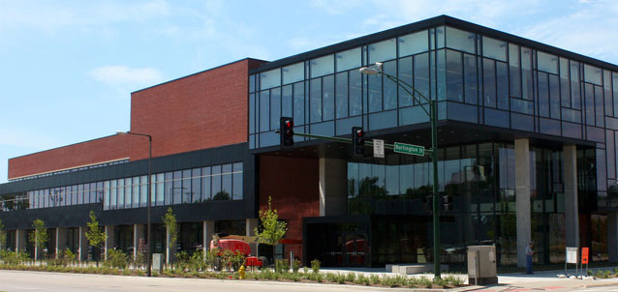
- 20,000 square feet of cardiovascular machines and weight equipment
- 3 multi-purpose courts
- Jogging track
- 51 ½ foot rock climbing wall
- A 50-meter competitive swimming pool
- 25 person hot tub
- Lazy river

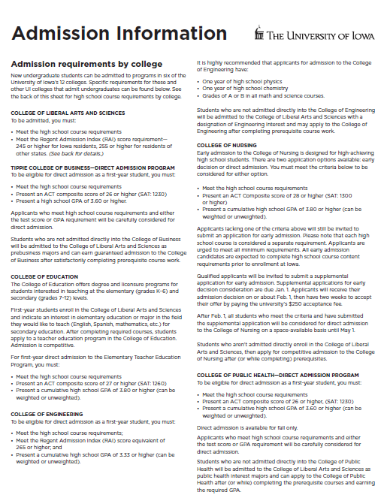
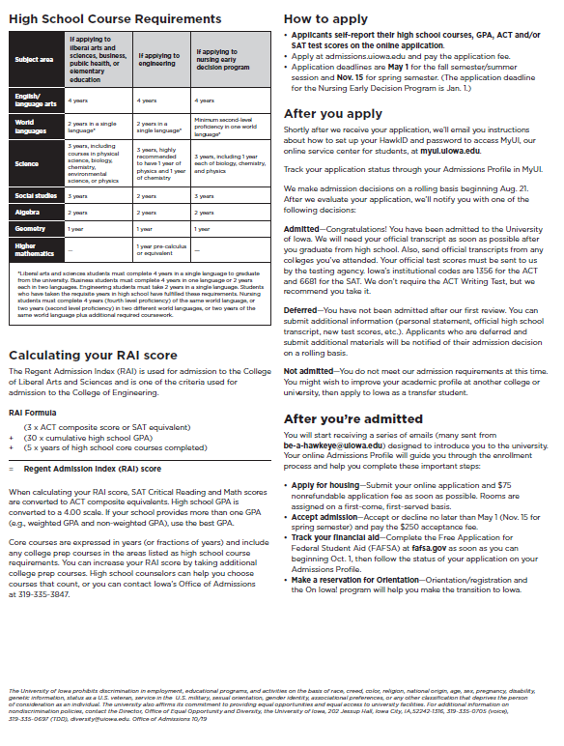

New Buildings

Several new buildings have opened their doors or are in progress of being built on the UI campus since 2016.

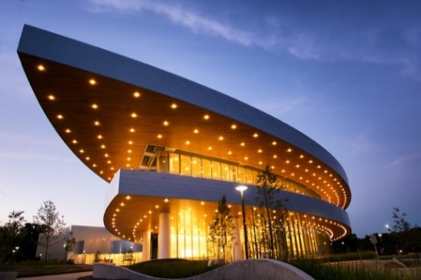
Hancher
This performing arts center was originally built in 1972 but was destroyed beyond repair in the flood of 2008. The new building opened in September of 2016. Hancher welcomes renowned acts every year in dance, music, and theater. Notable performances have included Book of Mormon, Mama Mia, and Leslie Odom Jr. Students can get tickets to most shows for $10 and there are some free shows throughout the year. Located on the north side of campus.
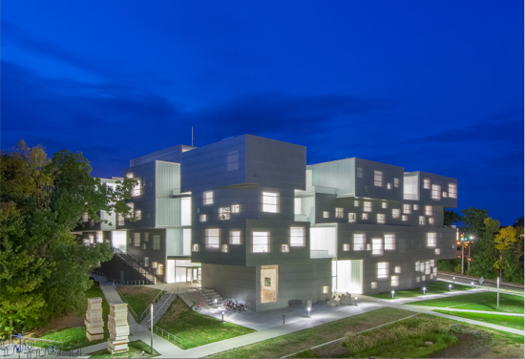

Visual Arts Building
This is a new home to the School of Art and Art History. The building opened in October 2016. It has won several accolades for its architecture including Interior Design Magazine Best of the Year in Education, and Architect’s Newspaper Building of the Year, Midwest. It’s located on the west side of campus.

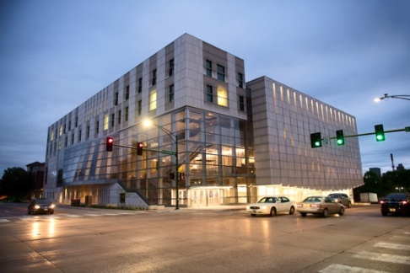
Voxman Music Building
The new music building opened in October 2016, putting the entire School of Music under the same roof for the first time since the 2008 flood. The building boasts acoustically perfect private practice rooms, a 1,883 pipe organ, a rooftop study space, and two recital halls. The state-of-the-art building was designed with sound in mind. It’s located in the heart of downtown on Burlington and Clinton streets.

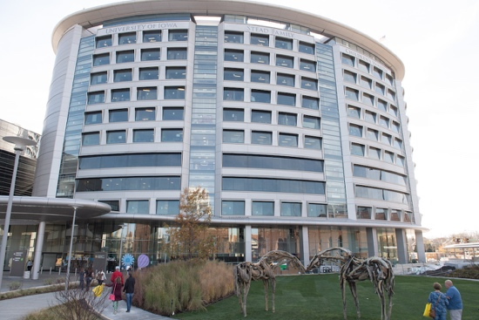
Stead Family Children’s Hospital
Overlooking Kinnick Stadium, the new children’s hospital opened its doors in early 2017. One feature of the hospital is a viewing space for Hawkeye football on the top floor. At the first football game of the 2017 season, 75,000 fans turned to wave to the kids in the hospital after the first quarter, creating a brand new tradition.

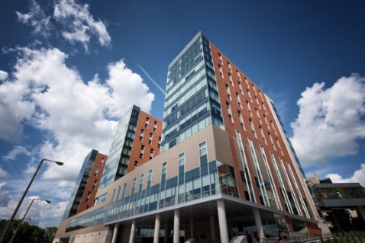
Catlett Hall
The UI opened its newest and largest residence hall in July 2017. Named after Elizabeth Catlett, who was one of the first three MFA graduates from the UI and the first African American to receive the degree. The 12-story building houses 1,049 students, has a dining hall, a recreation room, a workout facility, many study spaces including small group rooms, and a late-night food window. Each tower represents a “house” that holds certain Living Learning Communities.
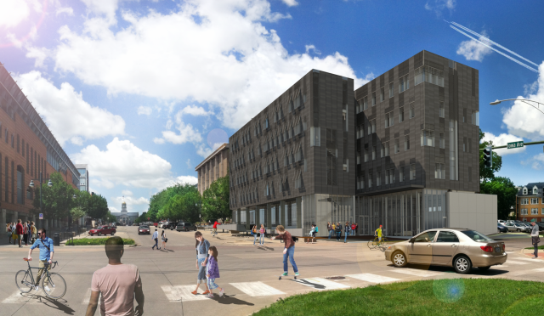
College of Pharmacy – in construction, set to open early 2020
The UI College of Pharmacy’s 210,000-square-foot facility was designed to foster collaboration and community. The college is well known for its high-quality pharmacy education, advanced practice models, patient care, drug discovery, product development, and contract manufacturing. The new building brings 23 learning spaces, 10 mock consultation rooms, program/cohort pods that provide students with lounge spaces and lockers, a 128-seat, team-based learning center, an active learning center that can transform from two 60-seat classrooms to a 300-seat seminar space and 16 collaborative laboratory science research ‘hybrid’ spaces.
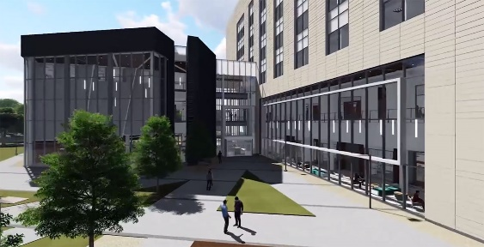
Psychological & Brain Sciences Building – in construction, set to open late 2019
The 64,000-square-foot building will be comprised of a mix of offices, dry laboratories, collaboration spaces, classrooms, and student work areas. The building will have a direct connection to Spence Labs, which is where the Psychological and Brain Sciences Department is currently housed.

University of Iowa Center for Advancement—IOWA Clubs

Recognized IOWA Clubs are the perfect way to bring the UI to your neighborhood. Since the UI Center for Advancement reinstituted its IOWA Clubs program in 1988, alumni and friends in Iowa and across the country have banded together to light the UI spirit in their own communities.

Each of our IOWA Clubs has its own character, but they all work to maintain the bonds people have with the University of Iowa. Clubs host networking events, game-watch parties for Hawkeye fans, raise scholarship funds for local students attending the UI, and provide a sense of fellowship and fun among their members.

If you want to take an active role in planning or participating in local activities, visit foriowa.org/clubs to find the club nearest you. For more information or to start a new club, e-mail Alumni.iowaclubs@foriowa.org or call 800-648-6973.

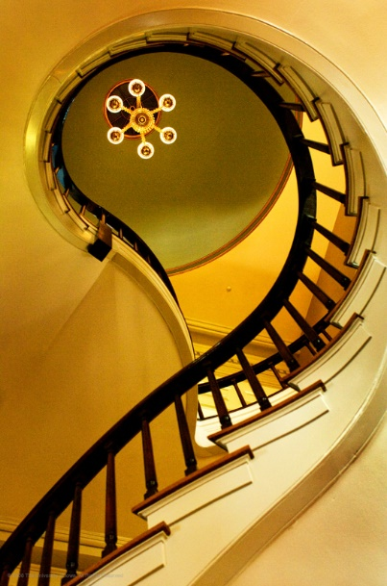

College Fairs

What is a College Fair?

College Fairs (or College Day/Night Programs) present the University an opportunity to meet with many students, and often their parents, in the course of a day or evening. Programs usually include representatives from many colleges and universities. These programs may be held in gymnasiums, student commons, cafeterias, shopping malls, meeting halls, etc. Several hundred to several thousand students and their families may attend.

The purpose of these events is generally to provide “overview” information to students and their families. Because these programs are often held in convenient locations and at convenient times they allow students to actually go “window shopping” for colleges.

ASIST members may choose to attend college fairs in their area and represent the University to prospective students. You may also attend busier fairs to assist our professional Admissions staff.

College Fair Procedures

- Before the program:

- Check materials: If you are the primary contact for a particular fair, you should receive a box of materials from the ASIST coordinator via FedEx minimally one week prior to the event – if not, call the coordinator immediately. Other volunteers for the fair will receive copies of directions and information the fair hosts provide the Office of Admissions.
- Contact others who are attending the fair. Review times of the event and if you are doing the fair in shifts, review your coverage times with the other UI volunteer(s).
- Review your ASIST Member Guide and the information packet you receive. Pay special attention to the Admission Information sheet usually included in the folder within the box. Review the Admissions booklet you will hand out at the fair; it contains basic admission, cost, and campus visit information.

- At the program:

- Schedule: Plan to arrive at least 30 minutes prior to the program. Find your table and arrange your materials before the program is scheduled to begin. We provide a black table cover and a yellow cloth table runner with the UI logo, UI tabletop photo display, and a listing of our academic programs.
- Student contact cards: You will receive student contact cards. These cards are filled-out by students that express an interest in the University; you will need to collect these cards and return them to the ASIST coordinator the same week as the fair. Encourage students to give e-mail addresses if possible and print clearly. Since many students are “shopping,” they can read the Admissions booklet and complete the online request form at www.uiowa.edu/admissions/undergrad/ask-us if they do not fill out a student contact card while at the table.
- If you run out of contact cards and booklets, get the student’s name, address, city/state/zip, e-mail and year in school on a piece of paper so we can mail them a copy later.
- Some publications sent to you (single copies) are samples for your reference only (i.e. Engineering Viewbook, Areas of Study at Iowa, Paying for Your Education at Iowa, etc.). The only publication which is essential to give the student is the Admissions booklet. Remember that the Office of Admissions will follow-up and send additional materials to the students who complete an information card. If there is a special request from a student, have them fill out a white card and write the request right on it.

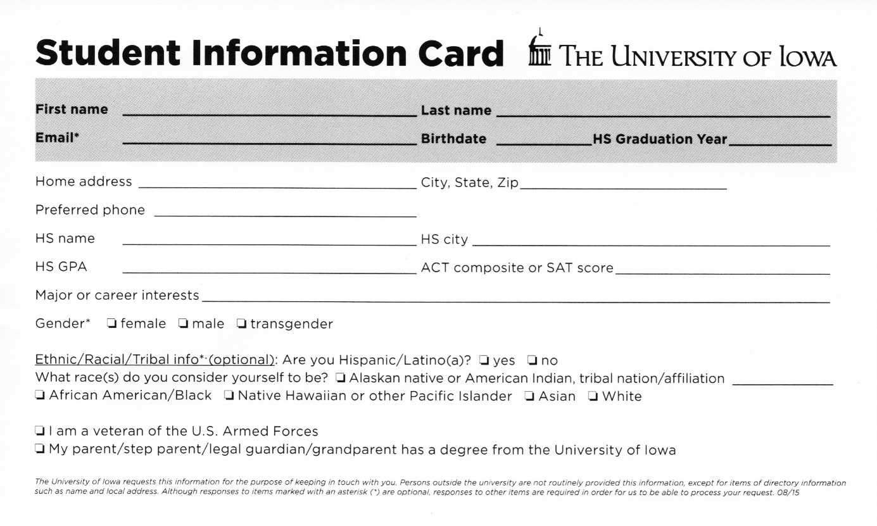

- After the program:

- Collect all student contact cards. Return them to the Office of Admissions in the envelope provided (or mail to: ASIST, 100 Pomerantz Center, Room C110; Iowa City, IA 52242-7700.)
- If you received a yellow cloth table cover with UI logo, return it in the pre-paid envelope provided (or mail to: ASIST, 100 Pomerantz Center, Room C110; Iowa City, IA 52242-7700.)
- Count materials. You should count your remaining Admission booklet supply and subtract from your original number to estimate the number of students seen at the fair. We must record the number of contacts you had at the fair. Estimate it if you have to. Do not return remaining booklets or other printed materials. You may want to ask the sponsor of the program if they can use the information for their files or ask a local high school if they would like it for their counseling office.
- Evaluation form: It is important that you complete the enclosed evaluation form, which will be emailed to you by the ASIST coordinator shortly after the fair. Your comments are important. We need to know if you had ample materials, how many students you contacted, your estimation of the quality and interest levels of the students you talked to, and your recommendation on whether or not the fair should be attended next year. If you don’t think we should attend again, please give as much specific information about your opinion as possible. Please return the evaluation as soon as possible.

Helpful hints

- Stand behind your table and look approachable. Students may often be shy and will not bother you if you are sitting behind the table reading a book or checking your phone or are talking to your neighbor. Students will welcome questions from you about their interests. Don’t call students over to your table, but do not hesitate to greet them and ask them if they are familiar with The University of Iowa. At some fairs you may be extremely busy and will only have time to hand out brochures.
- Don’t hesitate to admit that you don’t know the answer to a question. However, many answers are in the information provided (a good reason to review them before the fair). Refer to your personal experiences and put them into context of the diversity of experiences a student might expect to find at IOWA. If you are attending a fair with a staff person, always refer the question to the admission counselor if in doubt. MEMORIZE: 319-335-1566 and www.uiowa.edu.
- The Admissions website has a “Contact Us” link with all the different ways to get information. Students and parents can also e-mail the Office of Admissions at admissions@uiowa.edu.
- Respond with courtesy and tact to all questions from students and parents. You may think a question is silly, but it is important to the prospective student or parent nonetheless. If the question is about a sensitive issue (e.g. alcohol/drug usage, campus crime, language ability of teaching assistants, etc.) be mindful that these are concerns on many campuses and that the student or parents are genuinely concerned. Don’t be defensive or alarmed by questions of this nature. Be cautious in using “off-beat” humor or making other comments that students or their parents could interpret differently than you intended. Be sensitive to regional, cultural, gender, and orientation differences.
- Do not make admission guarantees to any student. Refer to admissions guidelines and encourage qualified students to apply for admission. Encourage marginal students to contact the Office of Admissions directly with any questions or concerns.
- While you may be asked to compare IOWA to other universities, do not speak negatively of other institutions. Speak only about what IOWA has to offer. We do not try to “hard sell” any student.
- Dress accordingly: Admissions personnel will dress professionally; sometimes “business casual.” Anything too casual may not leave the best impression. It’s usually better to overdress than under dress for these programs. Jeans, t-shirts, and sweatshirts are not acceptable.
- Refer ALL athletic recruiting questions to the Athletic Department and/or specific coaches. A listing of our coaches and their contact information is included in the ASIST manual.

If attending a national college fair sponsored by NACAC:

- Only three representatives, including alumni, can staff an exhibit booth at one time.
- When speaking with students, you must remain behind the table at all times. Talking to students and distributing materials in the aisles is not permitted.
- All exhibits must conform to the specified dimensions of the individual booth space and may not violate any building rules or ordinances. Balloons, stickers, and elaborate displays are not permitted at the fairs.
- Exhibitors are expected to arrive on time at the fair and staff the booth during the fair hours.
- Plastic bags, bumper stickers, buttons, pennants, candy, pencils, pens and other advertising and/or promotional items may not be distributed.
- The selling of products by exhibitors during the college fair is prohibited.
- Disseminating information that has no relevance to the college fair and/or the institution is prohibited.
- Audio visual equipment is permitted but must be confined to the participant’s booth. Volume levels must be kept to a minimum.

If for any reason you cannot attend the program you are scheduled for, contact Annabelle Vinson, ASIST Coordinator at (319) 467-0340 ASAP. Additional contacts in case Rachel is not available include: Tina Merta at 319-335-1562 and Sheila Schechinger at 319-335-1997.

It is NOT acceptable to just not show up at a fair; they have paid to have a table with our name on it and other schools may have been turned away for us to be there.

Next Step, Iowa Receptions

The purpose of “Next Step, Iowa” receptions is to provide admitted students with important information they may need before they begin their first year. This is frequently the last contact we have with the student before summer Orientation & Registration and the first contact we have with many parents.

The greatest contribution by ASIST members is a show of support, not only for the University, but most importantly for the students who can come to know you as their local source of information and guidance.

Newly admitted students and their parents from selected areas are invited to attend a reception near them. Programs are usually held annually in our primary market areas of Chicago and Minneapolis/St. Paul. In some years, depending on enrollment trends, we may also host events in Iowa and other metro areas in surrounding states. These programs are not necessarily held in the same locations every year.

Invitations go out approximately one month prior to the reception. Traditionally, receptions have been held from mid-February through mid-March.

Each program lasts about 2 hours and is usually held on a weekday evening. Receptions are held in hotels or meeting rooms, and we host from 75 - 600 people at each event. Historically, about 67% of students who attend receptions enroll at IOWA.

ASIST member duties could include helping Admissions staff with any of the following:
- One-on-one conversations with students and their parents
- Registration
- Hosting refreshment table
- Greeting guests as they arrive
- Helping staff from the college or academic department they graduated from at Iowa
- Ushering and seating guests
- Collecting questions from the audience
- Mixing & mingling
- Evaluation & feedback

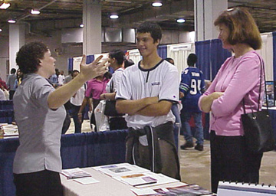
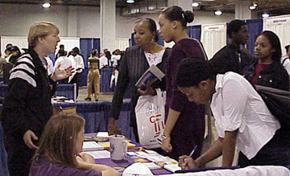

Engineering ASIST (Alumni Seeking Iowa Students)

Engineering ASIST is a collaborative effort between the College of Engineering, Office of Admissions, and UI Center for Advancement. Volunteers in this program have joint membership in the broader ASIST program, but will be able to share their specific experiences related to engineering with prospective students interested in that field of study.
Website: www.engineering.uiowa.edu/future-students (includes Engineering viewbook, scholarships, etc.)
Summary
Engineering at Iowa offers a tremendous education combining the advantages of learning in a small, team-oriented college and the opportunities (and fun) of being in a Big Ten Tier-1 Research Institution.
Engineering Majors
Bachelor of Science in Engineering (BSE) degrees are available in:
- Biomedical Engineering
- Chemical & Biochemical Engineering
- Civil & Environmental Engineering
- Electrical & Computer Engineering
- Industrial & Systems Engineering
- Mechanical Engineering
- Computer Science & Engineering
- Undeclared Engineering: most popular major for incoming students
  - All students in engineering take first three semesters in common, so no disadvantage in starting “undeclared”
  - Can still complete degree in eight semesters (four years)
  - Students unsure whether to start in engineering or in a Liberal Arts & Sciences or Business major AND who are admissible to engineering -- MUCH better to start with engineering, as these courses will count in other majors, but the reverse is not necessarily true

Admission – Apply early for admission (summer before senior year) and for housing immediately after being admitted

FIRST-YEAR STUDENTS:

- Meet the Regent Admission Index (RAI) equivalent of 265 or higher
- And meet the Minimum High School Course Requirements (which includes 4 years of math and 3 years of science, highly recommended to have one year of chemistry and one year of physics, ideally with all grades of A or B)
- Present a cumulative high school GPA of 3.33 or higher

TRANSFER STUDENTS:

- Students can transfer into engineering after completion of two courses: Calculus I and either the equivalent to Iowa’s Principles of Chemistry I (Chem:1110) or Introductory calculus-based Physics (PHYS:1611) with grades of A or B.
- As and Bs in any subsequent math, science, and engineering courses taken.
- Completion of high school unit requirements.
- The University of Iowa required a minimum transfer GPA of 2.50.

Academics
Direct admission into engineering and focus on student success from day one; rather than a weed-out philosophy and a year of "pre-engineering" which is typical at many engineering schools, makes engineering at Iowa unique. Students are admitted into the engineering major of their choice right from the start (or undeclared engineering) and can change their major at any point. There are no GPA cutoffs or quotas by department.
- All engineering students at Iowa take a three-semester common core, which gives students time to figure out which major is the right one while still being able to graduate in 8 semesters
- All engineering degrees at Iowa are set up to be completed in 8 semesters, and the majority of students do this
- Within the curriculum, every student selects an elective focus area (EFA) to specialize in an engineering topic or to add a liberal arts or business component to their degree
- Faculty members teach all engineering classes at Iowa. Teaching assistants (TAs) are used as assistants to the faculty members and another valuable resource (not instead of faculty members)
- Class sizes – largest classes are Chemistry & Physics with approx. 300 people in lecture, 25-person discussion sections, and 20-24 person labs. Engineering has two big classes which are capped at 150 students in lectures, 30 students in project groups.
- All engineering departments have a “fast track” option through which students can earn a BS and an MS in engineering in five years.
- Iowa was the 1st school in the U.S. to offer a Technological Entrepreneurship Certificate for engineering students interested in small business development or entrepreneurial skills

Size
The college is small (about 600 new freshmen each year; 2,445 total undergrads) which provides a lot of personal attention and incredible opportunities all while on a Big Ten campus with tremendous opportunities for students: athletics, music, leadership, fun…-- the "best of both worlds"

Emphasis
Students are encouraged to become "engineers ... and something more"—the interesting, multi-talented engineering students are also athletes, musicians, artists, campus leaders, researchers, volunteers, intramural champions, etc.! Great feeling of camaraderie in Engineering at Iowa – students are encouraged to work together rather than see each other as competitors.

Research
Engineering students have a lot of opportunities to get involved in undergraduate research from freshman year on. Engineering students are paid to work in research labs.

Diversity
- Underrepresented minority students comprise 16% of Iowa’s Fall 2018 engineering freshmen
- Women in Engineering @ Iowa exceed the national average of 20%; over 27% of Iowa’s Fall 2018 engineering freshmen are women
- Approximately 50% of engineering students are from Iowa, 33% are from Illinois, 11% are from other states, and 6% are from other countries

Resources
- Free tutoring program five nights a week for all math, science, engineering courses taken during the first three semesters
- Center for Technical Communications to assist students in writing, communication skills; see https://www.engineering.uiowa.edu/current-students/support-resources/hanson-center-technical-communication/why-visit-hanson-center
  - Engineering OAS1S = Outreach, Admissions, Scholarships, Inclusion Services and 1st Year Experience.
  - Engineering Student Services includes advising, tutoring, honors, study abroad, and career development
- Engineering students are strongly encouraged to live in an engineering living learning community: People in Engineering (PIE) or Women in Science & Engineering (WISE); apply for housing as soon as admitted

Career Information
- Comprehensive Engineering Professional Development office; co-ops/ internships (highly recommended but not required) very important to do for learning aspect and marketability; data on companies our students work at: http://www.engineering.uiowa.edu/epd
- Two engineering career fairs held each academic year; over 100 companies
- May 2016 placement rate: within 7 months of graduation, 94% of students had job in their major or had met their next academic goal (admitted to med school, law school, etc.);

Scholarships
- http://admissions.uiowa.edu/finances/scholarships
- Engineering First-Year (application deadline January 1, 2020), app at scholarships.uiowa.edu
- The University of Iowa is one of the first ten engineering schools (and the first of two in the Big Ten) selected by the National Academy of Engineers to host a Grand Challenge Scholars program. http://www.engineering.uiowa.edu/grand-challenges-program-description

Saturday Visit Days
- Explore Engineering@Iowa visit days, 10/5/19 and 12/7/19 from 8am-4:30pm, register in advance at http://admissions.uiowa.edu/visit-campus/visit-options-first-year-students

Rankings
- Engineering at IOWA ranks among the top 20% of engineering undergraduate and graduate programs nationally by U.S. News & World Report.
For More Information

Engineering student ambassadors (upperclass engineering students) can be reached at http://www.engineering.uiowa.edu/future-students/visit-engineeringiowa/student-ambassadors

Contact Jane Dorman at engineering@uiowa.edu or at 319-335-5769

Web: http://www.engineering.uiowa.edu/ (includes Engineering viewbook, scholarship info, etc.)

Education ASIST

Education ASIST is a collaborative effort between the College of Education, Office of Admissions, and the UI Center for Advancement. Volunteers in this program have joint membership in Education ASIST and in the broader ASIST program, and will be able to share their specific experiences related to education with prospective students interested in this field of study.

“I am honored to lead a world-class institution with a strong tradition of academic excellence and that has offered outstanding teaching, research, and engagement opportunities for more than 165 years. Our faculty, staff, students, and alumni are leaders, scholars and innovators nationally and globally in fields ranging from teaching, standardized testing, and gifted education to rehabilitation counseling, psychology, reading research, and more. This is evident in everything from the high national rankings of many of our graduate programs to the excellent placement rates of our Hawkeye teacher leaders across the state, nation, and globe. In fact, our teacher preparation program is consistently ranked the No. 1 program in the state of Iowa and 86 percent of our graduates are still in education five years post-graduation, much higher than the national average of 51 percent. Our Teacher Education Programs are also amongst the highest ranked in the nation, with our Secondary Education Program in the top 2 percent in the nation and our Elementary Education Program in the Top 6 percent in the nation.” -Daniel L. Clay, Dean, College of Education

Why Study Education at Iowa?

The University of Iowa College of Education is well known for offering a sophisticated curriculum that provides solid preparation for careers in education. The College of Education’s strong relationship with the College of Liberal Arts and Sciences makes Iowa’s education programs unique in their breadth, depth, and opportunity for diverse learning experiences.

Specialty programs within the College rank among the nation’s Top 20 according to “America’s Best Graduate Schools 2020.” They include: Rehabilitation Counseling ranked #9, Student Counseling and Personnel Services, #11 and Higher Education Administration ranked #16. The Secondary Education Program is in the top 2 percent in the nation and then Elementary Education Program is in the Top 6 percent in the nation, according to the National Council on Teacher Quality.

In addition to their innovative teaching, the College’s 90 faculty members are actively engaged in research and service. They have formed numerous partnerships with community school districts throughout Iowa to create and investigate new methods of teaching and learning. They also provide a wide range of outreach services by supplying valuable information and support for teachers, administrators, counselors, and communities. Faculty members work collaboratively with K-12 educators, assist school districts with curriculum development, provide counseling services, and administrator workshops for professional development and continuing education.

The College is also home to the Iowa Testing Programs, developers of the Iowa Assessments®. As a leader of gifted education, the College’s Connie Belin & Jacqueline N. Blank International Center for Gifted Education and Talent Development offers services, support, and programs for academically gifted and talented students and their teachers from pre-K through college level. These activities touch the lives of children from a wide variety of regions, backgrounds, and abilities and have helped distinguish the College as one of the top programs for gifted education in the country.

The College also excels in the area of assisting learners with disabilities. The UI REACH (Realizing Educational and Career Hopes) program offers a two-year certificate, with a third-year option, for students with intellectual and learning disabilities. The first of its type at a major public university, REACH empowers these young adults to acquire the skills necessary to become independent, productive, and fully participating adults living and working in the community. All of these centers offer University of Iowa education students experience and opportunities to develop the skills necessary to succeed in 21st-century education professions.

Degrees
B.A., B.S., M.A.T., M.A., M.S., Ed.S., Ph.D.
Undergraduate non-degree programs
Minor in Educational Psychology, Minor in Human Relations

UNDERGRADUATE ADMISSION:
The college offers degree and licensure programs for students interested in teaching at the elementary (grades K-6) and secondary (grades 5-12) levels. First-year students enroll in the College of Liberal Arts and Sciences and indicate an interest in elementary education or major in the field they would like to teach (English, Spanish, mathematics, etc.) for secondary education. After completing required testing, field experience at the appropriate grade level, and required semester hour minimums, students apply to a teacher education program in the College of Education. Admission is competitive and considered and reviewed on an individual basis.
DIRECT ADMISSION:
First-year students who present an ACT composite score of 27 or higher and a high school GPA of 3.8 or higher are admitted directly to the Elementary Teacher Education Program pending testing and field experience requirements completed by January of their first-year on campus. First-year students who present a high school GPA of 3.0 or higher are directly admitted to the Music Education Program (pending a successful audition to the School of Music) pending testing and field experience requirements completed by January of their first-year on campus.

Admission Requirements
Admission requirements may vary by program and are based on demand and faculty availability. Faculty members in each program area review and select students to be admitted to their program. Additional requirements may be stipulated on a program-to-program basis. TEP application materials and current minimum application requirements are available at https://education.uiowa.edu/future-students/teacher-education-program-application-and-admission .

In order to be considered for admission to a teacher education program, an undergraduate student must have met the following criteria:
- Been admitted to the University of Iowa College of Liberal Arts & Sciences with the appropriate subject area major or indicate Elementary Education Interest.
- Attained sophomore standing (completed at least 30 semester hours) prior to the semester during which application for admission to the Teacher Education Program is made
- Completed the Application for Admission to a Teacher Education Program, and submitted all of the required materials
- Completed a Post High School 10-hour Pre-Admission School Field Experience and submitted the signed verification form before the deadline
- Submitted minimum scores on the PRAXIS Core exam (Reading 156, Writing 162, and Mathematics 150) by the application deadline. Sufficient scores on the GRE are accepted as an alternative to taking the Praxis Core

The College of Education offers teacher preparation programs based on bachelor’s degrees. Elementary Education is a College of Education major leading to a Bachelor of Arts degree. The wide variety of secondary education programs combine a liberal arts and sciences bachelor’s degree academic major with teacher preparation coursework.

The College also provides numerous specialized elementary and secondary teaching endorsement programs. Preparation for special education teaching is offered primarily at the graduate level. In addition, a program for teaching students with mild/moderate disabilities is available as a specialization for students admitted to the Elementary Education major.

Application Deadlines
Priority deadline is October 1 for spring semester admission, with rolling admission through December 1
Priority deadline is March 1 for summer session or fall semester admission, with rolling admission through May 1

Iowa Firsts

- 1855 - The University of Iowa opens its doors as the first state university to admit men and women on an equal basis.
- 1870 - The University’s Medical Department, which will become one of the nation’s premier public medical colleges, holds its first sessions. With eight women in its original class, it is America’s first co-educational medical school.
- 1872 - The University creates the nation’s first permanent college-level department of education.
- 1873 - The first woman to graduate from the University’s Law Department, Mary B. Hickey Wilkinson, receives her Bachelor of Laws diploma. She is possibly the first woman to earn a law degree in America.
- 1873 - Rev. Stephen N. Fellows becomes the first permanent chair in teacher training at the collegiate level in the United States.
- 1879 - G. Alexander Clark, the son of the first black American ambassador, Alexander Clark, Jr., becomes the first African American in the Iowa Law Department – and possibly the nation – to earn a law degree.
- 1893 - Zoology professor Charles C. Nutting was roundly criticized for taking women students on what is believed to have been the first expedition in the nation to include women student/researchers.
- 1895 - Frank “Kinney” Holbrook is believed to have been the first African American to compete in varsity athletics at an Iowa college and one of the first black collegiate athletes in the nation.
- 1896 - The nation’s first intercollegiate basketball game with five players to a side and rules is played between Chicago and Iowa in Close Hall. Iowa coach, Henry Kallenberg, got the rules from his friend, James Naismith, the game’s inventor.
- 1897 - Carl E. Seashore begins the study of Speech Pathology, the first program of its kind in the country. The program is currently rated as one of the top in the nation.
- 1898 - University of Iowa Hospitals and Clinics opens – the first university-based teaching hospital west of the Mississippi. Eventually it will be the largest such university-owned institution in America.
- 1907 - The School of Education establishes the first chair of pedagogy at a U.S. university.
- 1907 - Mildred Whitcomb is named editor of The Daily Iowan, becoming the first woman to head an American college daily.
- Early 1900’s - The College of Pharmacy becomes the first college in the nation to dispense all drugs and medicines used by a hospital.
- 1920s - The Department of Graphic and Plastic Arts becomes the first in the country to base appointments on a prospective professor’s artistic abilities and portfolio quality.
- 1924 - After the University’s pioneering decision to accept creative work in lieu of academic theses from graduate students in the arts, Eve Drewelowe earns Iowa’s first Master of Arts degree in painting.
- 1927 - Iowa becomes the first tax-supported university to establish a school of religion. Iowa is also the first state university to offer a Ph.D. degree in religion.
- 1932 - UI Hospitals organizes the nation’s first and only statewide hospital ambulance service for patients unable to pay for their own transportation. It currently serves approximately 12,000 patients yearly.
- 1932 - W9XK, the world’s first educational television station, airs its premiere telecasts. Sound is transmitted over campus radio station WSUI.
- 1934 – George Nissen, a Hawkeye gymnast and diver, and Larry Griswold, another gymnast created the first trampoline using a piece of canvas stretched around an angle iron frame. Eight years later, they started the Griswold-Nissen Trampoline and Tumbling Company in Cedar Rapids, IA.
- 1935 - David A. Armbruster, the first Hawkeye swimming coach, originates the butterfly stroke and the flip turn. Eight years earlier, he developed underwater observation windows.
- 1935 - E.F. Lindquist, professor of education, develops the Iowa Tests of Basic Skills (ITBS), a measure of academic achievement that will later be taken by students in every state and in several foreign countries. Lindquist went on to set the standard for researchers in testing and measurement throughout his 40 years at the University, developing the Iowa Tests of Educational Development and helping to create the American College Testing program and its college entrance exam, the ACT. His invention of an electronic scoring machine, revolutionized the educational testing business.
- 1936 - America’s first university-sponsored program in creative writing, the Writers’ Workshop, is established.
- 1938 - The College of Pharmacy establishes the nation’s first hospital pharmacy graduate program.
- 1939 - Iowa establishes the first blood bank in the nation to use preservative agents for long-term storage.
- 1940 - The University grants a Master of Fine Arts degree – the first in the country. Elizabeth Catlett Mora, African-American sculptor, is one of the first three students to earn it.
- 1940’s - Buffered aspirin is born when UI dietician Kate Daum complains to Professor of Medicine William D. “Shorty” Paul of a headache. She says she couldn’t take aspirin because it made her sick. So Paul grinds together a combination of aspirin and antacid, which cures her headache without making her nauseous. Bristol-Myers later learns of Paul’s remedy and eventually markets the product as Bufferin.
- 1947 - University Hospital School, the first program on a college campus devoted to rehabilitating disabled children and young adults, opens its doors to its first 20 patients.
- 1948 - The School of Journalism awards the first doctoral degrees in the nation in mass communication.
- 1952 - The nation’s first cryobank for frozen semen is established at Iowa.
- 1954 - Iowa is the first university in the nation to offer a doctorate in Hospital and Health Administration.
- 1954 - Jewel Limar Prestage becomes the first black woman to receive a doctorate in political science from a U.S. university.
- 1955 - Ophthalmology Department doctors are the first in the nation to enlist state highway patrol officers to rush donor eyes to them for corneal transplantation. The department later becomes the first to train morticians to remove corneas for transplantation.
- 1955 - The world’s first Institute of Agricultural Medicine and Occupational Health opens at Iowa to study problems on the farm and in workplace.
- 1955 - The University establishes the western hemisphere’s first institute of agricultural medicine and environmental health to study problems on the farm and in work places.
- 1955 - The UI Cleft Palate Research Program, the first multi-specialty rehabilitative program for cleft palate patients, is established.
- 1957 - Hawkeye team captain, Simon Roberts, becomes the first African American to win an NCAA wrestling championship.
- 1958 - Using data from America’s first earth satellite, Explorer I, UI Physics Professor James A. Van Allen discovers belts of radiation surrounding the earth, a phenomenon that eventually will be called the Van Allen Belts. The cosmic ray instruments aboard Explorer I are the first of many that the University will provide for U.S. satellites, rockets, and space probes.
- 1961 - With Injun I, Iowa becomes the first university to completely design, assemble, and operate an entire spacecraft. It will repeat this feat at least seven more times and distinguish itself as one of only two universities in the world to do this.
- 1963 - The Unit Dose System, a national standard, is originated at Iowa.
- 1967 - Paul Engle and Hualing Nieh bring 27 writers from 18 countries to Iowa City as they found the International Writing Program, the first and only program of its kind in the world.
- 1972 - Hancher Auditorium, a performing arts center that will gain national stature, opens to acclaim for its exceptional acoustics and for a computerized lighting system that at the time is found in only one other theater, the Royal Shakespeare in Stratford-upon-Avon.
- 1972 - Lilia Abron becomes the first African American woman in the nation to receive a doctorate in chemical engineering.
- 1973 - The first-ever survey of Jupiter’s radiation belts using Pioneer 10 is performed by James A. Van Allen.
- 1975 - Dentistry Professor George F. Andreasen first uses nitinol wire on orthodontic patients. Known as the “wire with a built-in memory,” it reduces the time required for braces.
- 1979 - James A. Van Allen discovers and surveys Saturn’s radiation belts using Pioneer II.
- 1979, 1980, 1981 - Original University Theatres plays by students in the Playwrights Workshop are selected three years in a row for performance at the American College Theatre Festival at Kennedy Center in Washington, D.C. Iowa is the only university ever to be present at three consecutive festivals.
- 1981 - William R. Panje in the Otolaryngology Department invents the neolarynx or “voice button,” enabling people to speak after removal of the larynx.
- 1982 - A package of UI instruments carried aboard the Space Shuttle Columbia becomes the first scientific payload to be picked up with the shuttle’s mechanical arm.
- 1983 - C. Vivian Stringer, becomes the first African American to coach a Big Ten women’s basketball team.
- 1984 - The College of Dentistry establishes the Infant Oral Health Clinic, the first of its kind in the world.
- 1987 - Nancy Andreasen, professor of psychiatry, wins the Foundation’s Fund Prize for Research in Psychiatry, the highest award for research given by the American Psychiatric Association. Andreasen is the first woman to receive the award.
- 1987 - Assistant professor of Civil and Environmental Engineering Konstantine P. Georgakakos creates the system for flash flood prediction used by the National Weather Service.
- 1989 - The University of Iowa Mental Health Clinical Research Center, dedicated to the study of schizophrenia, receives a grant of $3.6 million from the National Institute of Mental Health. The multidisciplinary center, the largest of its type in the United States, is directed by Nancy Andreasen, professor of psychiatry.
- 1989 - The College of Law’s Writing Resource Center opens to provide writing and editorial guidance to students and faculty. It is the only law program of its kind in the country.
- 1989 - The country’s first national Hispanic sorority, Sigma Lambda Gamma, is founded by a group of UI students.
- 1990 - The Iowa Political Stock Market (IPSM), which made its debut during the 1988 presidential elections, gains international notoriety when it predicts the outcome of the first all-national elections in Germany.
- 1991 - Professor of Anthropology Russel Ciochon’s search for the remains of Gigantopithecus in the jungles of northern Vietnam earns worldwide attention and is the subject of a National Geographic special. The dig is the first joint scientific project between the U.S. and Vietnam since the end of the war.
- 1992 - UIHC neurologists develop Brainvox, a technique that combines magnetic Resonance Imaging, applied mathematics, and computer technology to create a three-dimensional reconstruction and analysis of the brain.
- 1993 - Iowa Professor Donald Gurnett, principal investigator for plasma research experiments aboard the Voyager spacecrafts, is able to map the approximate distance to the heliopause, that point in space where our sun’s radiation influence ends and intergalactic space begins, hundreds of millions of miles from Earth.
- 1993 - UI Hospitals and Clinics establishes an outreach agreement with the Keokuk County Medical Clinic in Sigourney. The Program is the first in what is hoped to be a network of clinics designed to make health care more accessible to rural Iowans.
- 1993 - UI was the first university and public institution of higher education in the nation to offer domestic partner insurance coverage beginning in January, 1993
- 1994 - The University of Iowa Museum of Art celebrates its 25th year. The museum is the only university museum in the country to be established entirely through donations.
- 1994 - Through the use of brain-imaging technology, psychiatry professor Nancy Andreason discovers that the single cause for schizophrenia may be abnormalities in the thalamus.
- 1995 - KRUI, the University’s student-run radio station, becomes the nation’s first, fully digital college radio station.
- 1996 - Students interested in the history of the book and the art of book design and production can now earn credit for their studies in a new graduate-level program offered by the Center for the Book. The nondegree certificate in Book Studies/Book Arts and Technologies is the only certificate program of its kind in the United States.
- 2008 - UI was the first university outside of China to arrange for a corps of student volunteers at this year’s Olympic Games. Two dozen UI students, mostly Journalism majors, serving as media volunteers with the Iowa Olympic Ambassadors Project.

Notable Alumni

- Leland C. Adams-former president, Amoco Production Co. BSEE 1948, Electrical & Computer Engineering
- Nancy Andreasen-Psychiatrist, internationally renowned for her work on schizophrenia and creativity. M.D., 1970.
- B.J. Armstrong-Professional basketball player with the Golden State Warriors, formerly with the Chicago Bulls. Played on the Bulls' NBA Championship teams in 1991, 1992, and 1993. B.A., 1989, Communication Studies
- John J. Balles-former president, Federal Reserve Bank of San Francisco. BSC 1942, M.A. 1947, Economics
- Mildred Wirt Benson-Creator of the Nancy Drew mystery story collection. B.A., 1925; M.A. 1927, Journalism and Mass Communication
- Clark Blaise-author; 1964 English
- David Bonior-Congressman. B.A. 1967 Political Science
- Terry Branstad-Governor of Iowa, and longest-tenured Governor in the nation. B.A., 1969, Political Science; Has previously taught at The University of Iowa in the Tippie College of Business.
- Tom Brokaw-anchorman, NBC News (attended, did not graduate from UI)
- Mitchell Burgess-Executive Producer, The Sopranos. B.A. 1978
- Robert Olen Butler Jr.-Won the 1993 Pulitzer Prize for fiction, among other literary awards. M.A., 1969, Communication and Theatre Arts
- John R. Camp-1986 Pulitzer Prize winner; M.A. 1971, Journalism & Mass Communication
- Elizabeth Catlett-Acclaimed painter who studied under Grant Wood and is the first African American woman to earn the MFA from the University of Iowa. MFA, 1940, Art
- Marquis Childs-1970 Pulitzer Prize Winner; St. Louis Post Dispatch; M.A. 1925, Journalism & Mass Communication
- John Cochran-correspondent, ABC News. B.B.A. 1975; M.B.A. 1988, Accounting
- Arthur Collins-Founder, Collins Radio (Rockwell Collins)
- Max A. Collins, Jr.-Writer of the comic strip "Dick Tracy." (Chester Gould was the creator of the strip and Collins took over in 1977 when Gould retired.) Collins also writes mystery novels. B.A., 1970; M.F.A., 1972, English
- Paul Conrad-Former editorial cartoonist for the Los Angeles Times who won the Pulitzer Prize in 1964, 1971, and 1984. B.A., 1950, Art
- Kathleen A. Dore-President, Bravo Television Network. B.A. 1972; M.B.A. 1984, Communication and Theatre
- Rita Dove-Won Pulitzer Prize for poetry and was the 1993 Poet Laureate of the United States. M.F.A., 1977
- R. Wayne Duke-former commissioner, Big Ten Conference. B.A. 1950, Journalism & Mass Communication
- Tim Dwight-Outstanding UI football player and track star; Atlanta Falcons, San Diego Chargers, and now with the New England Patriots - 2005. B.S. 1999, Sports, Health, and Leisure Studies
- Paul Engle-Poet and director of the Iowa Writers' Workshop for 24 years. Engle also founded the International Writing Program. M.A., 1932, English. Died 1991.
- John W. English-former vice president & chief investment officer, Ford Foundation
- Simon Estes-World famous baritone, formerly of the New York Metropolitan Opera. B.M., 1986
- John Falsey-executive producer of television’s Northern Exposure and I’ll Fly Away. M.F.A. 1978, English
- Jane K. Fernandes - introduced on May 1, 2006, as Gallaudet’s ninth president. Earned both a master’s and doctoral degree in Comparative Literature. Gallaudet University is the world renowned university in liberal education and career development for deaf and hard-of-hearing undergraduate students.
- Robert Gallery-football player, Oakland Raiders; #2 NFL draft pick, 2004. B.A. 2003, Elementary Education
- George Gallup-Founder of the Gallup Poll. B.A. 1923, Political Science; M.A. 1925, Psychology; Ph.D. 1928, Psychology
- Bob Gebhard-Executive V.P. & General Manager, Colorado Rockies. B.S. 1966, Physical Education
- Jorie Graham-Pulitzer Prize winning poet and MacArthur Fellow who is on the faculty of the Iowa Writers' Workshop. M.F.A., 1978, English
- Charles Guggenheim-A Washington, D.C.-based documentary filmmaker who has won three Academy Awards and been nominated for eight others. B.A., 1948, Communication and Theatre Arts
- Milo Hamilton-sports announcer; Chicago Cubs, Houston Astros, Chicago White Sox
- Katherine Hammer-A former professor of linguistics, Hammer is co-founder, president and CEO of Evolutionary Technologies International, a company that is revolutionizing the way corporations worldwide modernize and consolidate incompatible computer systems. B.A., 1967; M.A., 1969; Ph.D., 1973.
- Robert C. Hardin-Developed blood bank protocols during World War II. B.A., 1935; M.D. 1937.
- John Hawkins-Retired President, Kemper Financial. B.A. 1936 Commerce and Science
- I. J. (Jim) Holton-Retired Chairman & CEO, Hormel & Co. B.A. 1941 Economics; J.D. 1947, Law
- General Charles A. Horner-architect of the U.S. air war against Iraq during the Persian Gulf War
- Mary Beth Hurt-actress, The Big Chill, others. B.A. 1968 Communication and Theatre
- John W. Irving-Novelist who wrote The World According to Garp, A Prayer for Owen Meany, and several others. M.F.A., 1967, English
- Al Jarreau-Jazz singer and 1982 Grammy Award winner for best male pop performance. M.A., 1964, Education
- Mark Johnson-Producer and Oscar Award winner for the movie Rainman. M.A. 1973, Communication and Theatre
- Donald R. Justice-Pulitzer Prize winner for poetry. Ph.D., 1954, English
- Alex Karras-football player and actor. Former student
- Barry M. Kemp-Executive producer of several television series including "Coach" and "Newhart." B.A., 1971, Communication & Theatre Arts
- Tracy Kidder-Author of The Soul of a New Machine, Among Schoolchildren, House and Old Friends. M.F.A, 1974.
- W.P. Kinsella-Author of critically-acclaimed bestseller Field of Dreams, which was made into a major motion picture. M.F.A., 1978, English
- Shirley Rich Krohn-casting director for Kramer vs. Kramer, Three Days of the Condor, Taps, and Saturday Night Fever
- Ashton (Christopher) Kutcher-actor, That ‘70’s Show, movies. Former engineering student in the 1990’s.
- Richard S. Levitt-Vice Chairman, Norwest Corp. (now Wells Fargo). B.A. 1952, Economics; J.D. 1954, Law
- E.F. Linquist-Co-founder of American College Testing (ACT) Ph.D. Education, 1927
- Jack A. MacAllister-former President, US West (now Qwest). B.S.C. 1950, Commerce and Science
- Richard W. Maibaum-Screenwriter and producer who wrote Broadway plays and thirteen James Bond scripts/films. B.A., 1931; M.A., 1932, Communication and Theatre Arts. Died 1991.
- John McLendon-1st Black coach inducted into Basketball Hall of Fame. M.A. 1937, Physical Education
- James Alan McPherson-Pulitzer Prize winning author and MacArthur Fellow who is currently on the faculty of the Iowa Writers' Workshop. M.F.A., 1971, English
- Nicholas Meyer-Film writer and director whose film credits include Time After Time, The Seven Per-Cent Solution, and Star Trek II. B.A., 1968, Communication and Theatre Arts
- Randall Meyer-former President, Exxon Co. BSME 1948, Mechanical Engineering
- Marjorie Mowlam-Former Minister of State, Northern Ireland. M.A. 1974; Ph.D. 1977, Political Science
- Herbert Nipson-Award-winning journalist who spent nearly forty years of his professional career at Ebony magazine. Executive editor 1972-87. M.F.A., 1948.
- (Mary) Flannery O'Connor-Novelist and author of numerous short stories. M.F.A., 1947, English. Deceased 8/4/64
- Henry Bates Peacock-one of the original founders of Texas Instrument. B.A. 1921; M.S. 1922; Ph.D. 1925
- Gordon Prange-Author of Tora, Tora, Tora; M.A. 1934, Ph.D. 1937 History
- W. Ann Reynolds-Chancellor of the City University of New York and former Chancellor, California State University. M.S., 1960; Ph.D., 1962, Zoology
- Eddie Robinson-legendary football coach, Grambling State University
- Kim E. Rosenblum-V.P. & Creative Director, Nickelodeon Network. B.A. 1987 Communication Studies and Spanish
- Brian Ross-correspondent, NBC News; Peabody and Emmy award winner. B.A. 1971, Journalism & Mass Comm.
- Richard Schultz-executive director, United States Olympic Committee; former executive director, NCAA
- Cory SerVaas-Editor and publisher of The Saturday Evening Post. Inventor, medical doctor, and the mother of five children. B.A., 1946, Journalism and Mass Communication, M.D., Indiana University School of Medicine
- Carole Simpson-anchor, ABC News
- Jane Smiley-1992 Pulitzer Prize winner for fiction for the novel A Thousand Acres. M.A., 1975; M.F.A., 1976; Ph.D., 1978, English
- Mary Louise Smith-Former chair of the National Republican Committee, and former vice chair of the U.S. Commission on Civil Rights. B.A., 1935, Business Administration
- W.D. Snodgrass-Poet. B.A. 1949; M.A. 1951; M.F.A. 1953, English
- Richard Stanley-Founder & President, Stanley Consultants. M.S. 1963, Civil & Environmental Engineering
- Keith N. Steva-Director, e-Bay. BSEE 1973, Electrical & Computer Engineering
- Juanita Kidd Stout-First woman appointed as a federal judge; Pennsylvania Supreme Court Justice. B.A., 1939, Music
- Mark Strand-Poet Laureate, 1990. M.A. 1962, English
- Andrew Swift-Producer, E! Entertainment Television. B.A. 1988
- James Tate-Pulitzer Prize Winner, 1992. M.F.A. 1967 English
- Michael F. Toner-1993 Pulitzer Prize winner for explanatory journalism. B.A., 1966, Journalism and Mass Communication
- Tracy Ullman-Comedian, actress, producer. B.A. 1990
- James Van Allen-World famous physicist and discoverer of two radiation belts (the Van Allen Belts) that surround the earth. Emeritus Carver Professor of Physics at the University of Iowa. M.S., 1936; Ph.D., 1939, Physics
- Mona Van Duyn-U.S. Poet Laureate, 1992. M.A. 1943, English
- Margaret Walker-writer, Jubilee
- Tennessee Williams-Author of A Streetcar Named Desire and Cat on a Hot Tin Roof. B.A., 1938.
- Gene Wilder-Comedic film and television actor whose credits include Silver Streak, Young Frankenstein, and Stir Crazy. B.A., 1955, Communication and Theatre Arts

